NAME : G.LAXMI SRI
CLUSTER 3 SECTION 7
sPractical-3:
Task-1:
Compilation and Execution:
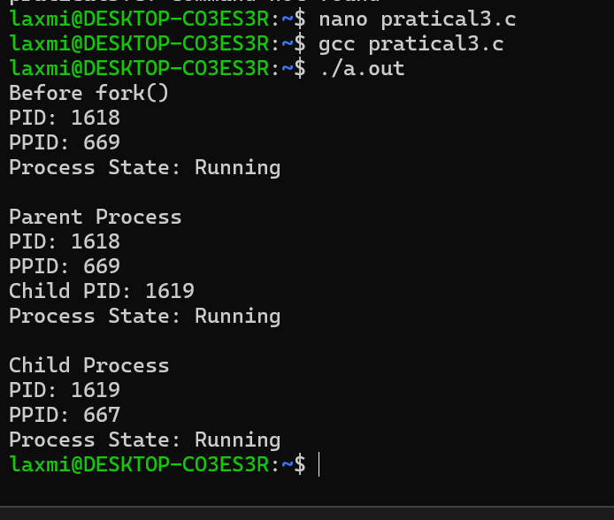

Task-2:
ps command:

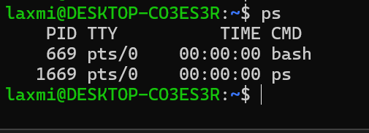

top command:
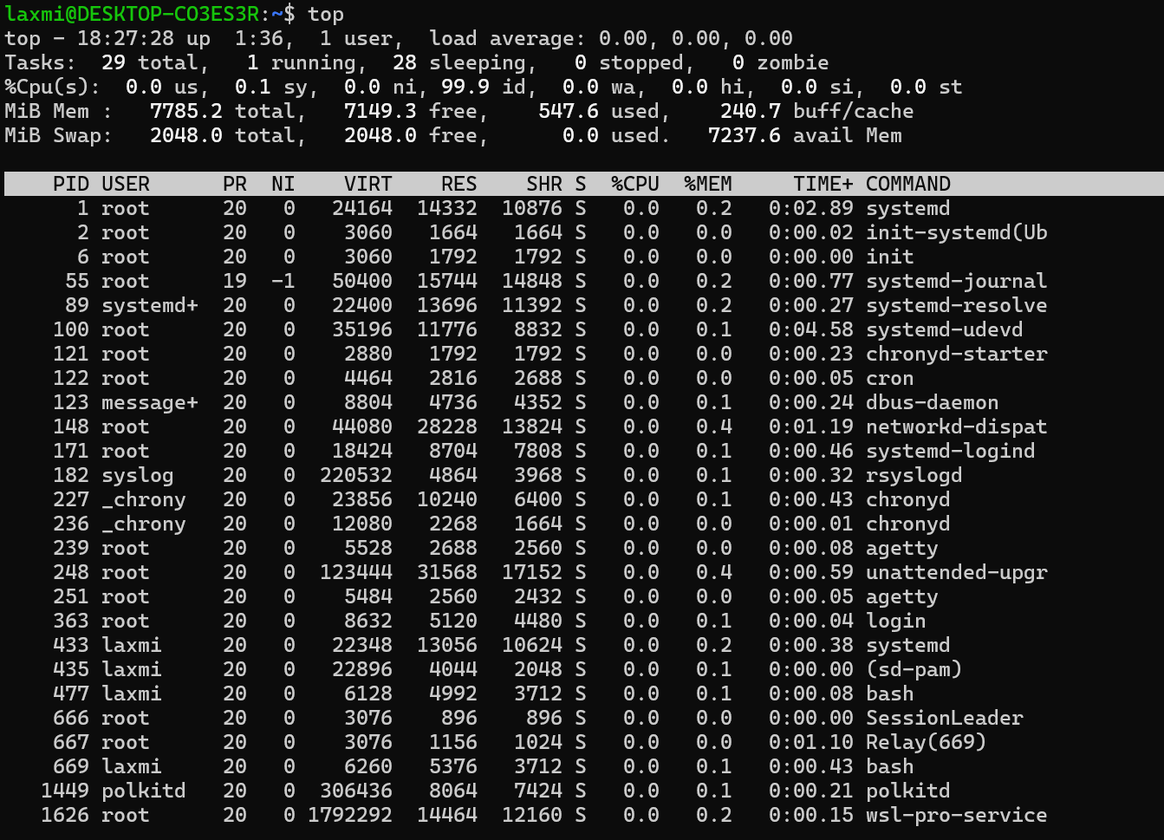

/proc:
